Database Engineer capstone project

1. Did you design a database model for the given scenario (Global Super Store)?

* Did you create a high-level conceptual data model?
* Did you design a logical ER diagram?
* Did you apply the three fundamental forms of normalization?

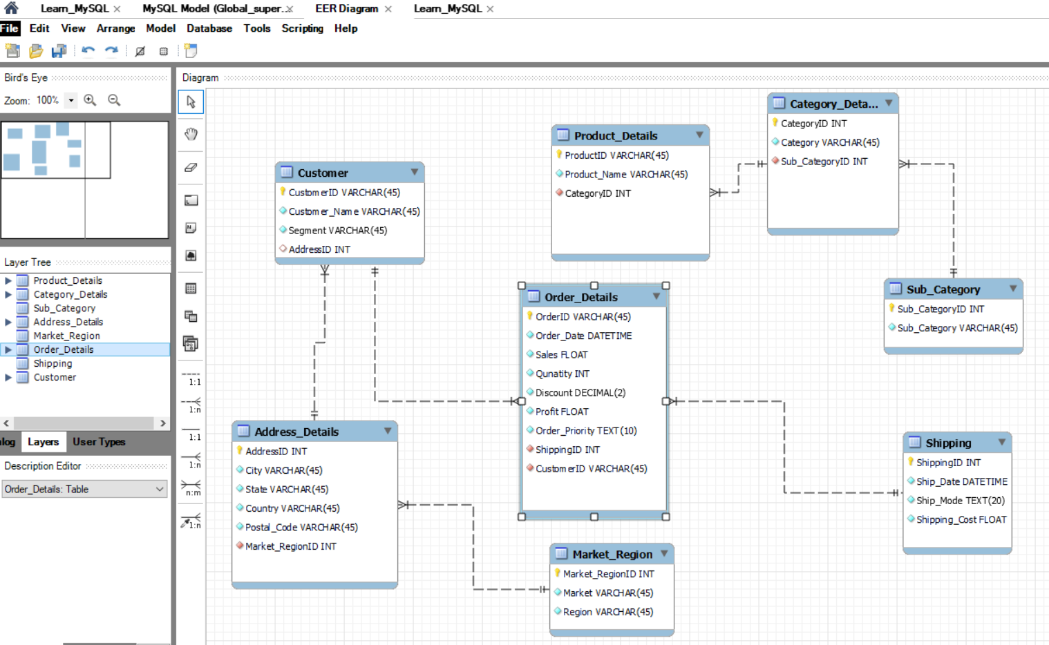

2. Did you set up and use the MySQL Workbench environment to develop your databases?

* Did you create the proposed database model using MySQL Workbench?
* Did you deploy the database schema inside MySQL server?
* Did you use the Forward Engineer method?
* Did you create a virtual table to summarize data from multiple tables?

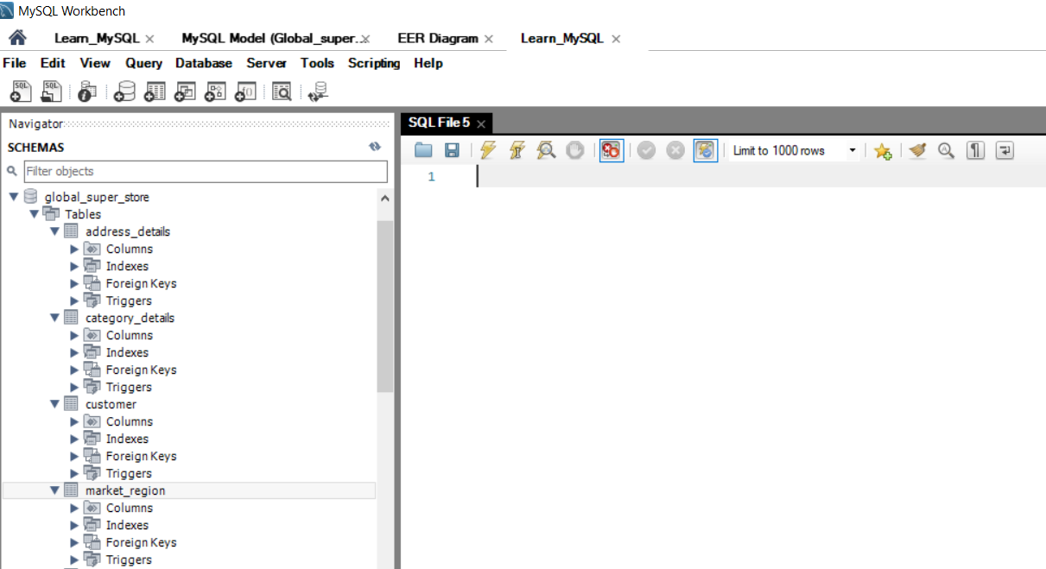

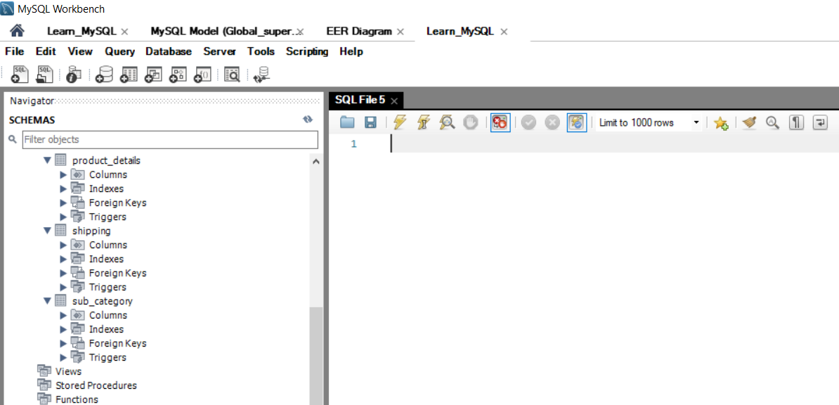

3. Did you help Global Super Store to design their dimensional data models?

* Did you use an appropriate approach for dimensional data modeling?

Yes. Below are the schemas

* Did you design a suitable Star Schema?

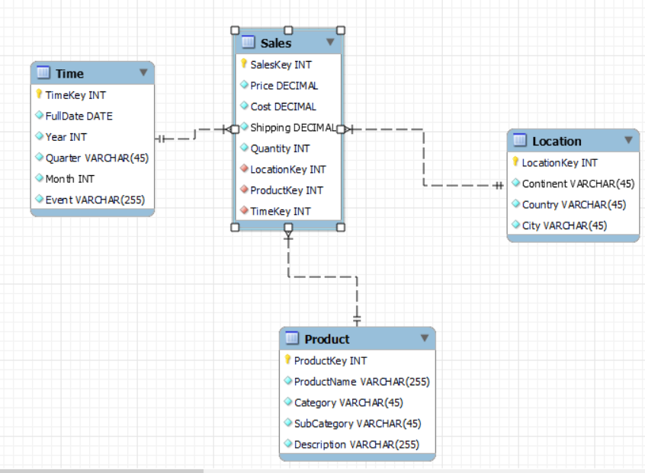

Step 4: Create a map chart

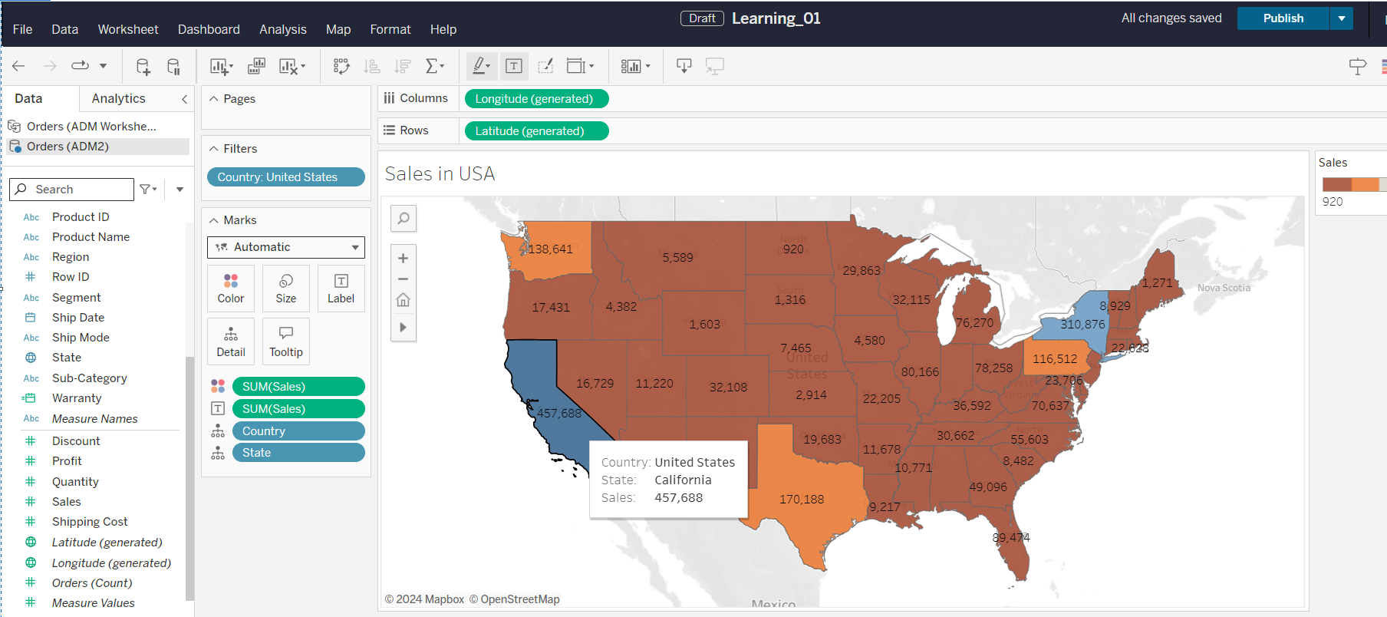

Step 5: Create a bubble chart

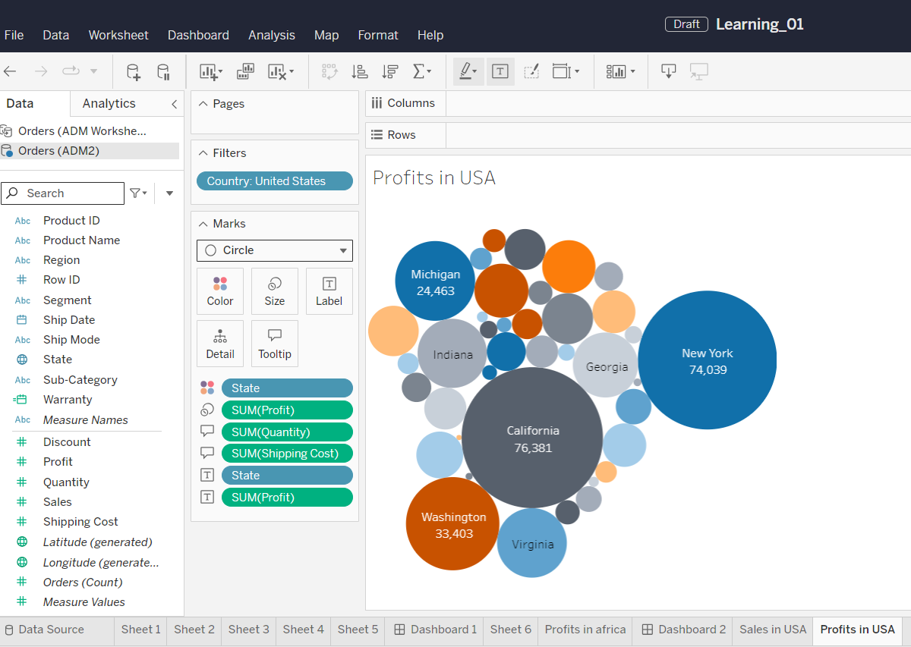

Step 6: Create a line chart

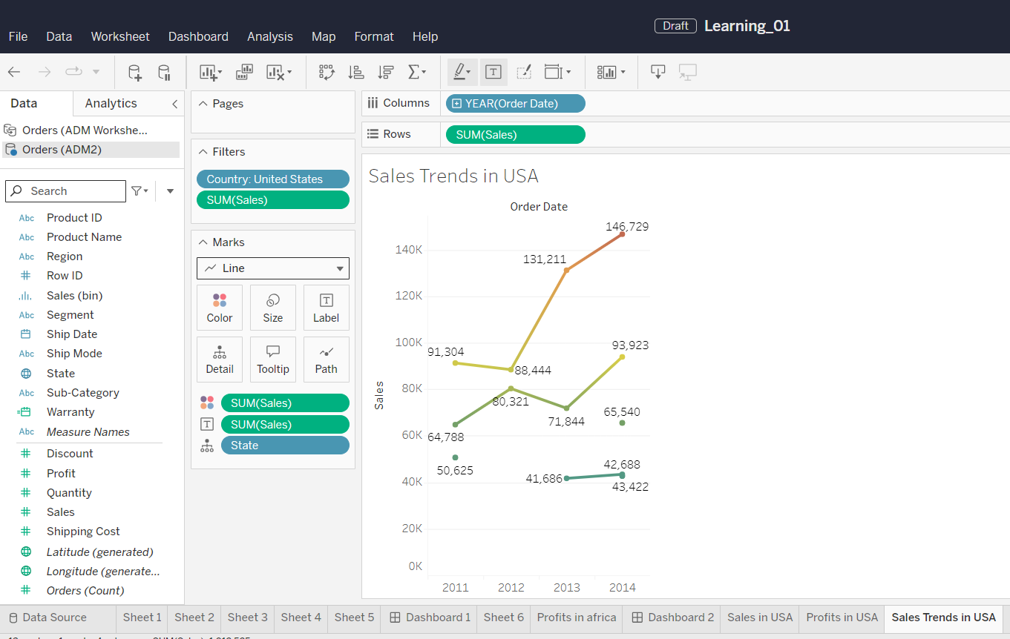

Step 7: Create an interactive dashboard

